Guided Practice for Polar Day 1
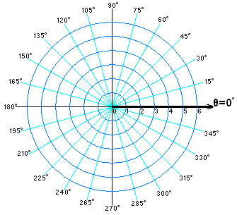
1. Convert the rectangular points to polar points and graph on the polar plane
a. (5,-3)

b. (7,11)

c. (-3, 0)

d. (-2,-9)

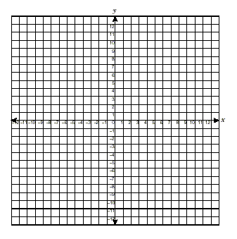
2. Convert the polar points to rectangular points and graph on the coordinate plane
a. (3, 40°)

b. (-4, 165°)

c. (2, -60°)

d. (-2,-135°)

3. Convert the following rectangular functions into polar functions
a. 3y – 7x=10

b. $x^{2}+y^{2}=25$
4. What is the difference in the graphs of the rectangular functions versus the polar functions?
5. Is one form better than the other?

6. Suppose you had the ability to choose which plane you would conduct your daily mathematical life in, polar or Cartesian. Decide which coordinate system you would prefer and give your reasons. Be sure to include why you would not want to work in the other system.

7. In class we discussed that the polar system was first used for navigation purposes. When else could this system be used?

8. Using your computer (or Smartphone if you have one) research briefly other places the polar coordinate plane appears in our life.

